Exercise 2 (Final exam)
Consider the two-port network (quadripole) shown in the figure below, constructed with two coupled voltage generators and four identical resistors of value R.
- Q: Express the impedance matrix [Z] in terms of R,
R: we have:$\left\{\begin{matrix}V_{1}=Ri_{1}+V \\ V_{2}=V-2V_{1}+Ri_{2}+V_{2}-3V \\ V=Ri_{1}+Ri_{2}+V_{2}-3V\end{matrix}\right.$ so $Z=\left[\begin{matrix}R/2 & R/4 \\ -3R & 0\end{matrix}\right]$ (2P)
- Q: Express the impedance matrix [Z] in terms of R, (1P)
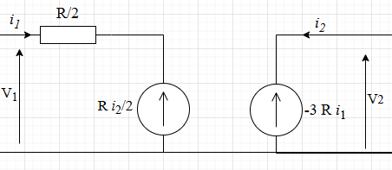
- Q: For the two-port network loaded with a resistance R_{L} at the output port, express in terms of E, R, and R_{L}:
- Voltage gain (A_{v})
- Input impedance (Z_{in})
- Output impedance (Z_{out})

R: we have $V_{2}=-R_{l}i_{2}$ so:
$A_{V}=\frac{V_{2}}{V_{1}}=\frac{-12 R_{L}}{3R_{L}+2R}$ (1P)
$Z_{in}=\frac{V_{1}}{i_{1}}=\frac{R R_{L}+6R^{2}}{2R_{L}}$ (0.75P)
$Z_{out}=\frac{V_{2}}{i_{2}}=-R_{L}$ (0.75P)

